Project 15: Fonts

Objectives:

At the end of this project, you will be able to:
- Use web-safe fonts in your web pages.
- Specify backup fonts in case your primary font is unavailable.

Instructions:

- Create a new folder called "Fonts".
- Create a new XHTML document and save it as "index.html" in the "Fonts" folder.
- Set the title to be "Fonts".
- Build a table with two columns and eleven rows. Using CSS, set the table to be 900px wide with no border.
- Make the first table row contain table header elements with 24px font size. Set all table cells with appropriate padding and make all text to be a uniform 20px in size.
- Create separate classes for each table row, specifying the indicated font and a fallback font of either serif or sans-serif, depending on the primary font.
- Re-create the following table as closely as possible:

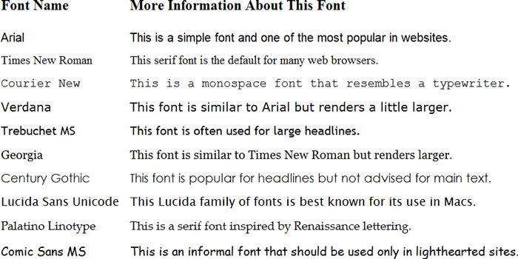

Rubric 15: Fonts

Name: ____________________________

Component | Possible Points | Score
Each of the main rows has the correct font specified. (2 points per row) | 20
Quotes surround all font names that contain spaces. | 2
Each font declaration has the appropriate serif or sans-serif fallback. | 3
Total Score | 25

